**Project Design Phase-II**

**Technology Stack (Architecture & Stack)**

|  |  |
| --- | --- |
| Date | 18-10-2022 |
| Team ID | PNT2022TMID13848 |
| Project Name | Personal Expense Tracker |
| Maximum Marks | 4 Marks |

**Technical Architecture:**

The Deliverable shall include the architectural diagram as below and the information as per the table1 & table 2

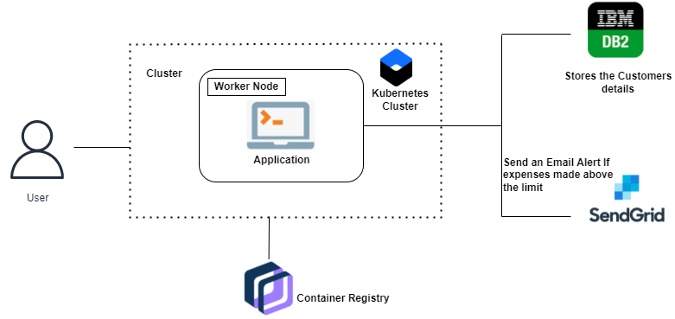

**Table-1: Components & Technologies:**

|  |  |  |  |
| --- | --- | --- | --- |
| **S.No** | **Component** | **Description** | **Technology** |
|  | User Interface | How the user interacts with application e.g.  Web UI, Mobile App, Chatbot etc. | HTML, CSS, JavaScript, Python Flask, etc. |
|  | User Login | User can able to login throw their email account. | Python Flask |
|  | Graph Visualisation | Rendering plots and graphs based on the user  spending data | Seaborn, Matplotlib |
|  | Database | Data Type, Configurations etc. | MySQL |
|  | Cloud Database | Database Service on Cloud | IBM DB2 |
|  | File Storage | File storage requirements | IBM Block Storage |
|  | SendGrid | A cloud-based SMTP provider that allows you to  send email without having to maintain email  servers | SendGrid is used to trigger mail to user  emails when a particular condition is  met. |
|  | Google OAuth | OAuth 2.0 allows users to share specific data with  an application while keeping their usernames,  passwords, and other information private. | Enables login through Gmail account,  thus making the application accessible |
|  | Infrastructure (Server / Cloud) | Application Deployment on Cloud | Cloud Foundry, Kubernetes, etc. |

**Table-2: Application Characteristics:**

| **S.No** | **Characteristics** | **Description** | **Technology** |
| --- | --- | --- | --- |
|  | Open-Source Frameworks | Python-based Flask is a microweb framework.  A microframework is what it is because it  does not call for specific tools or libraries | Python Flask Framework |
|  | Security Implementations | Python-based Flask is a microweb framework.  A microframework is what it is because it  does not call for specific tools or libraries | Use some of the crypto algorithms like rail fence transposition technique |
|  | Scalable Architecture | Containerized application is deployed too rapidly  increase scale on demand | Docker |
|  | Availability | This application will be available to user at any point of time | Container Registry, Kubernetes cluster |
|  | Performance | The performance will be high because the traffic will be less in the application | Kubernetes cluster |